Editorial contacts:
Heiko Hespen or Nick Foot
Billings Europe
Tel: +44-1491-636 393
Fax: +44-1491-636 383
heiko.hespen@billings-europe.com

Tyco split creates three separate companies

Energy Division stays part of Tyco Electronics

Witham – March 13, 2007 – In January 2006 Tyco International Ltd. announced its plan to separate the company’s current portfolio of diverse businesses into three separate, publicly traded companies – Tyco Electronics, the world’s largest passive electronic components manufacturer; Tyco Healthcare, one of the world’s leading diversified healthcare companies, and the combination of Tyco Fire & Security and Engineered Products & Services (TFS/TEPS), a global business with leading positions in residential and commercial security, fire protection and industrial products and services.

Tyco Electronics is keeping its name, however due to the split it will have a new logo and a completely new corporate identity including a new branding. The Energy Division will still be part of Tyco Electronics. Within the Energy Division of Tyco Electronics, the brands Dorman Smith, Crompton Instruments and Bowthorpe EMP form the Electrical Equipment Business Unit.

The separation of Tyco International’s different businesses is planned to be completed by the end of April 2007 and will be accomplished through tax-free stock dividends to Tyco shareholders, after which they will own 100% of the equity in three publicly traded
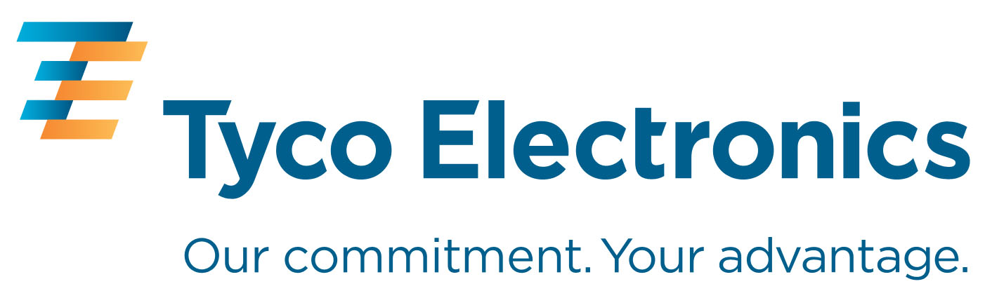

companies. Each company will have its own independent Board of Directors and strong corporate governance standards.

Tyco Electronics, Bowthorpe EMP, Dorman Smith are trademarks.
Crompton is a trademark of Crompton Parkinson Ltd., and used by Tyco Electronics under licence.

About Tyco Electronics – Energy Division
The Energy Division of Tyco Electronics is a global manufacturer of products and systems for the electrical power industry. Its products are extensively employed by power utilities and equipment manufacturers, in rail transport systems and in industry around the world.
The Energy Division of Tyco Electronics offers a wide product range from brands such as AMP, Axicom, Dulmison, Raychem, SIMEL, Bowthorpe EMP, Crompton Instruments, Dorman Smith and La Prairie, including cable accessories, connectors and fittings, switching and power management devices, lighting protectors, surge arrestors and insulators.
For further information please visit: www.energy.tycoelectronics.com

About Tyco Electronics
Tyco Electronics is a leading global provider of engineered electronic components, network solutions and wireless systems, with 2006 sales of $12.7 billion to customers in 150 countries. We design, manufacture and market products for customers in industries from automotive, appliances and aerospace and defence to telecommunications, computers and consumer electronics. With over 8,000 engineers and worldwide manufacturing, sales and customer service capabilities, Tyco Electronics' commitment is our customers' advantage. More information on Tyco Electronics can be found at www.tycoelectronics.com

For further information please refer to www.energy.tycoelectronics.com or contact:

Pavlina Dvorakova, Marketing Communications Coordinator,
Tyco Electronics – Energy Division, Witham, UK,
Tel: +44 (0)1376 509 509, Email: pavlina.dvorakova@tycoelectronics.com

